ISLM BOOKMARK EXCHANGE PROJECT ACTIVITIES 2019. - “Let's Imagine“
Country: CROATIA
Name : Anita Drenjančević
Title of your position: school librarian
School or organisation: Osnovna škola Josipovac - Primary school Josipovac
web link: http://os-josipovac.skole.hr/
http://os-josipovac.skole.hr/skola/knjiznica/aktivnosti/2019_2020_
http://os-josipovac.skole.hr/fotogalerija?show=album&id=327

Partners:
- III. osnovna sola Celje, Slovenija – Number of student sin the group: 32
- Valasarabela primary school, India - Number of students in the group: 37
- Kasiga school, India - Number of students in the group: 26

We designed our bookmarks together with our pupils and we made them in a six groups. Our
teachers and pupils research and study about our partners (Slovenia and India) countries in
school library. We photographed the process and we presented the project to the rest of
the school and with that we conclude this year participation.

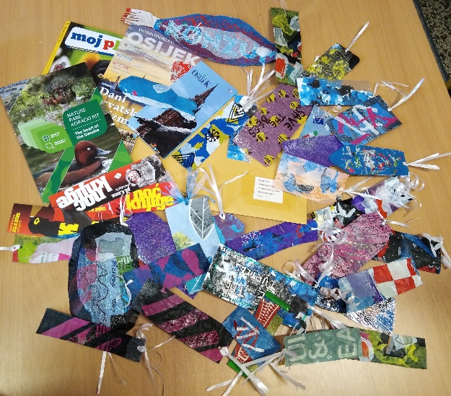
Eko- bookmarks –recycling of old plastic bags (8th grade students)
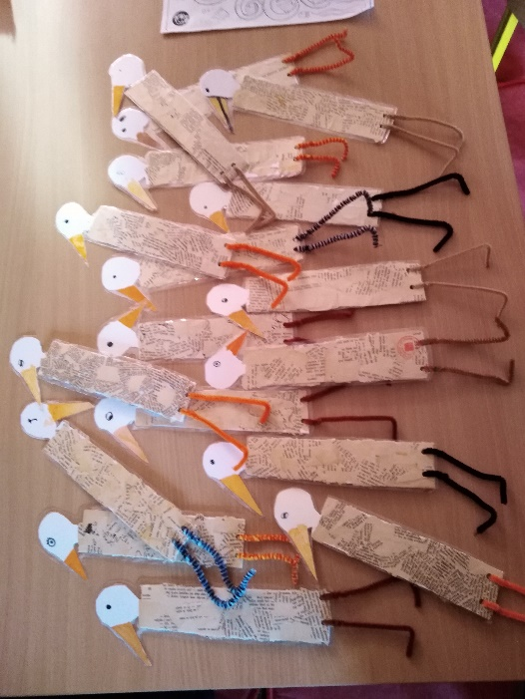
Eko-bookmarks – recycling old books (4th grade students)

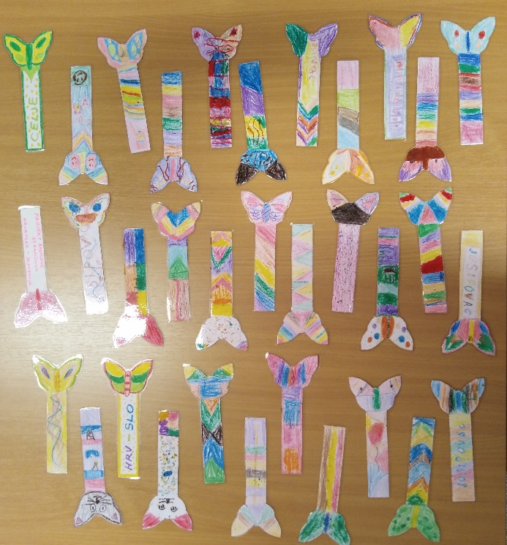
Let's imagine…cats and butterflies… playfulness, freedom…
(2nd grade students)

